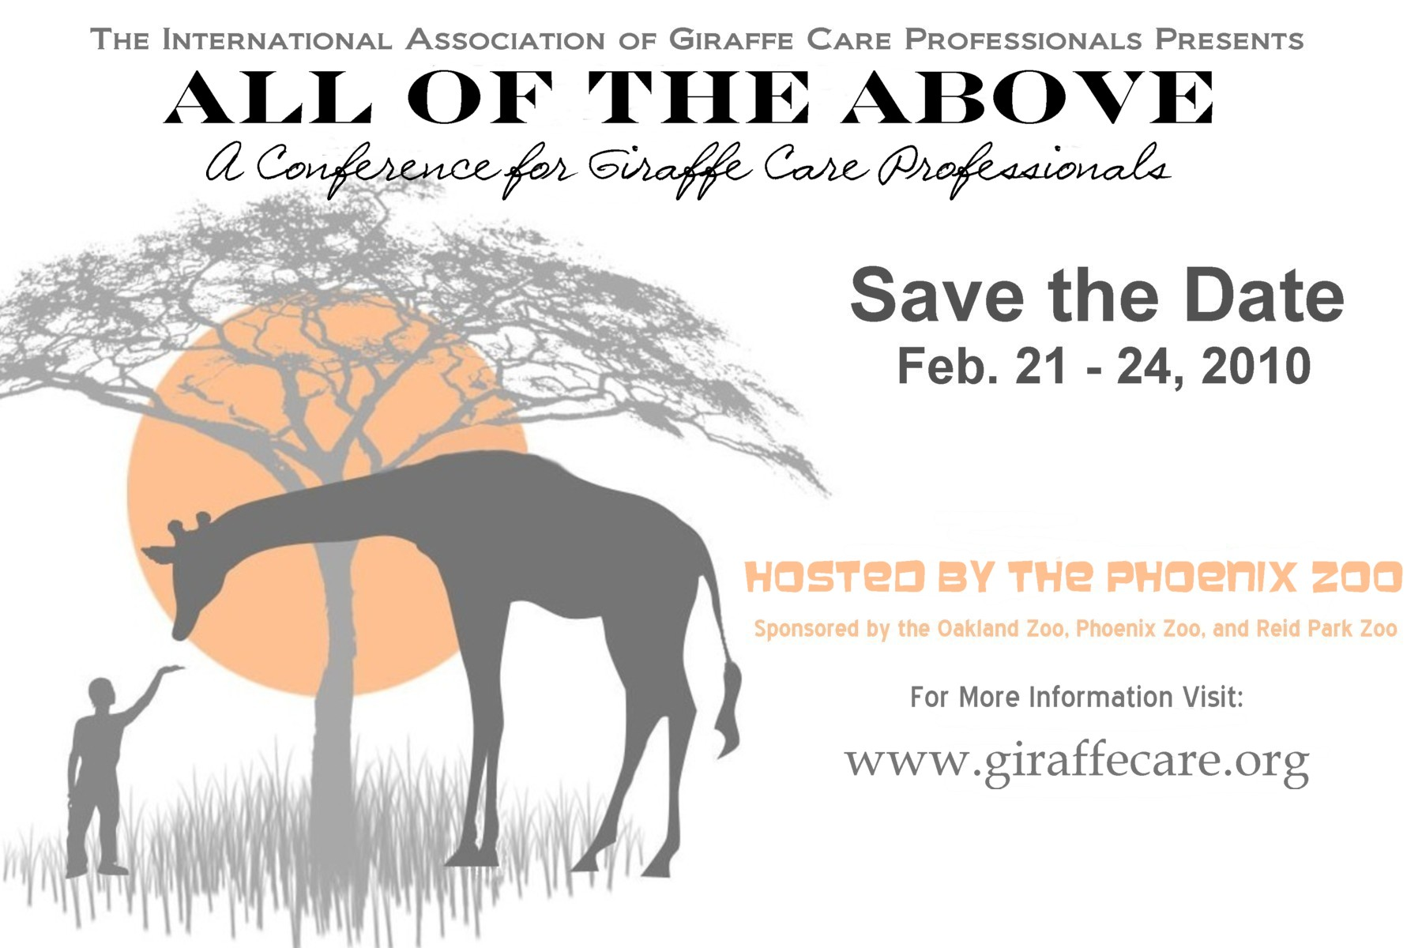

Calling all Zookeepers, Veterinarians, Field and Zoo Researchers And Giraffe Conservationists!

Mark your calendars for the Inaugural Giraffe Professionals Conference
Held at the Phoenix Zoo Feb. 21 – 24, 2010

- Keynote address by Julian Fennessy, Ph.D
- Featuring workshops on topics such as hoof care, nutrition, training, enrichment
- Additional discussions including anesthesia and standing sedation, conservation and field projects
- Now accepting paper and poster submissions through Nov. 15, 2009

Want more Information??

Visit us on the web at: www.giraffecare.org
Send us an e-mail: info@giraffecare.org
And look for us on Facebook

